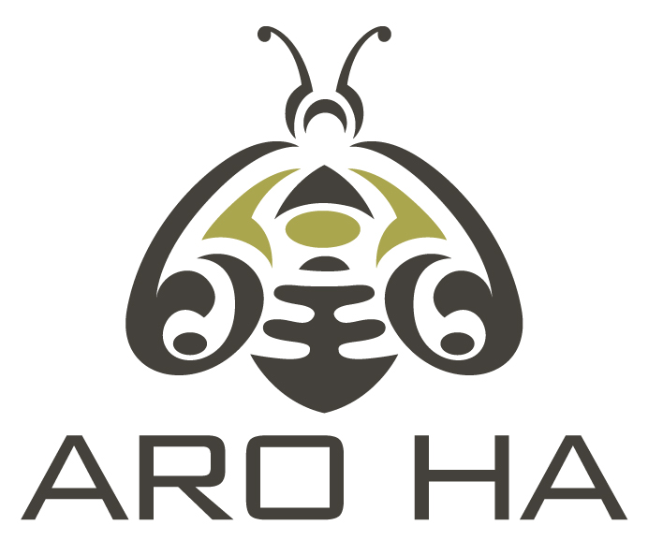

**Full time / Part time Housekeeper @ Aro Ha Wellness Retreat**

**Position Summary:** As a housekeeper at Aro Ha you will be part of a small team providing high standards of housekeeping during our retreats at Aro Ha Wellness Retreat.

**Position Responsibilities**

* Daily housekeeping of guests rooms, all guest facilities and staff areas including spa building
* Laundry including guests laundry as required
* Knowledge and understanding of effective cleaning methods and techniques using eco friendly products
* Attention to detail and high standards of cleanliness
* Adhere to all Health & Safety standards
* Other various tasks as assigned
* An eye for detail and ability to multi task

Roster works around our retreat schedule and includes weekend work

**Physical Requirements**  While performing the duties of this job: the employee must be able to work in a physically demanding environment; maneuver on uneven ground; stand for long periods of time; regularly lift and carry bags and bundles of linen, reconfigure guest rooms, lift, bend, carry, load and unload laundry in and out of commercial washing equipment.

You must be able to legally work in New Zealand

Please apply by 29 December 2024 email [office@aro-ha.com](mailto:office@aro-ha.com)

**www.aro-ha.com**