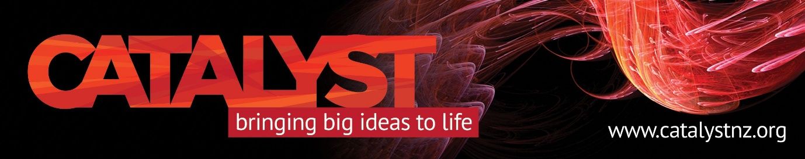

**The complex Middle East context of the Gaza war**

**Catalyst Kōrero, Sunday, August 18, Dr Leon Goldsmith**

Understanding the Israel-Palestine conflagration is impossible if viewed through a lineal Western lens, University of Otago politics researcher Dr Leon Goldsmith says.

He will outline the far more complex political and historical context that provides the real drivers of this conflict, with its very real scope for even greater humanitarian catastrophe and expansion of the conflict across the region, at our August 18 Catalyst Kōrero.

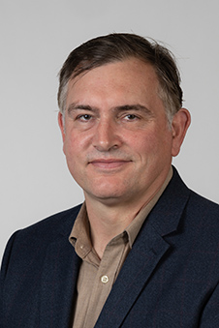Crises in Gaza and the West Bank have normally been framed around two overlapping pillars; the unresolved Israeli – Palestinian conflict and regional struggles between two broad camps.

These being the “resistance axis” (Iran, Syria, Hezbollah, Hamas and now the Houthis) and the “moderate” pro-Western Arab states (Egypt, Jordan and the Gulf Cooperation Council states).

Both camps have used the Israel – Palestine conflict as a “political hand grenade” over recent decades to harm each other, Dr Goldsmith says.

“The region is awash with quite brilliant, civic minded people deeply committed to helping their countries and region, including the Israel/Palestine catastrophe.

“The international community needs to listen more carefully for these voices, rather than the shrill rhetoric of extremists or the disingenuous statements of tyrants and their helpers.”

*Sunday, August 18, 6-7.30pm at The Rees Hotel Queenstown’s Ruma Wai Kahu on the fifth floor. Registration required* [*HERE*](https://events.humanitix.com/the-complex-middle-east-context-of-the-gaza-war/tickets)  *to ensure your seat. Please bring cash for your koha. This will be given to Médecins Sans Frontiers/Doctors Without Borders for their work in the region.*